

**LA GRANDEE INTERNATIONAL COLLEGE**

**Simalchaur, Pokhara Nepal**

A Project Proposal

On

**“Book Ecommerce”**

**Submitted to:**

Bachelor of Computer Application (BCA) Program

In partial fulfilment of the requirements for the degree of BCA under

Pokhara University

**Submitted by:**

|  |  |  |  |
| --- | --- | --- | --- |
| **Name:** | **Course** | **Semester** | **P.U. Registration Number** |
| Bishal Adhikari | BCA | 6th | 2019-00-00-0000 |
| Deepak Chhantyal | BCA | 6th | 2019-00-00-0000 |
| Roshan Adhikari | BCA | 6th | 2019-00-00-0000 |

**Date:29/09/2024**

# ACKNOWLEDGEMENT

The satisfaction that accompanies after the successful completion of any task will be incomplete without mentioning the people whose ceaseless and relentless cooperation, constant guidance and encouragement made this project proposal report possible.

We are grateful to our project supervisor **Mr Ritesh Thapa**, our faculty teacher **Mr. Ramesh Chalise**, and **BCA** coordinator **Mr Rishi Khanal,** for the guidance, inspiration and constructive suggestions that helped us in the preparation of this project.

We are also appreciative among each other and have understood that teamwork, the designation of the task per the skillset one portrays, constant synchronisation and monitoring of progress and instilling new knowledge and skill is imperative for the success of any given work.

Sincerely,

Generic Thapa

Generic Sharma

Generic Gurung

Generic Nepali

**DECLARATION FOR**

**“Book Ecommerce”**

# STUDENT’S DECLARATION

We hereby declare that we are the only authors of this work and that no sources other than the mentioned here have been used in this. We assure you that the work we present here is unique to ourselves and resemblances to another similar project are purely coincidental.

Generic Name (PU Exam Roll no): ___________________

Generic Name (PU Exam Roll no): ___________________

Generic Name (PU Exam Roll no): ___________________

Generic Name (PU Exam Roll no): ___________________

Program: BCA, 2nd Semester

Date: 29/09/2024

# SUPERVISOR’S DECLARATION

I hereby declare that the project entitled **“Book Ecommerce”** has been carried out under my direct supervision by Generic Name (PU Exam Roll no), Generic Name (PU Exam Roll no), Generic Name (PU Exam Roll no), Generic Name (PU Exam Roll no), and Generic Name (PU Exam Roll no) during their second semester for the partial fulfilment of the requirements for the degree of **BCA(Bachelors of Computer Application)** program under **Pokhara University**

**_______________**

**Mr Ritesh Thapa**

(Project Supervisor)

Date: 29 September 2024

**TABLE OF CONTENTS**

ACKNOWLEDGEMENT ii

STUDENT’S DECLARATION iii

SUPERVISOR’S DECLARATION iv

1. INTRODUCTION 1

2. PROBLEM STATEMENT 2

3. OBJECTIVES 3

4. METHODOLOGY 4

5. DATA FLOW DIAGRAM 5

6. PROJECT GANTT CHART/ TIMELINE CHART 6

7. DELIVERABLES 7

8. CONCLUSION 8

# INTRODUCTION

As first paragraph in the introduction is important, therefore, the introduction generally includes the definition of your project, for instance, the bus route management is a streamlined, intuitive and easy to use information system that attain information about a bus route and store them for later retrieval.

You can mention explanation on why you are creating the project ,what is the purpose behind selecting the project and what drove you to pursue this project.

Write about the background of the system, for example, Pharmacy management system is required because a pharmacist cannot remember all the names and prices of the medications, the billing procedure and data storage can also help manage inventory of the medicines.

What were your **major** findings while performing feasibility analysis and requirements analysis?

Can write about why implementing your system is important in that environment, write why going digital is the best method.

However, you should not completely disclose the problem statements in the introduction, because the introduction section is the general overview of the report.

Finally, think it as if you are going to introduce your project to a lay person who do not have much idea about the project and underlying technicalities.

# PROBLEM STATEMENT

In problem statement identifies the current scenario of the desired project and its context, the desired future scenario. What were the problems faced by the users interacting with the existing systems?

Common problems include data redundancies, paperwork, lesser flexible system, out-dated systems, unorganised tasks, and storage issues.

# OBJECTIVES

Very important and pivotal section and everything else in the project development is centred around it, so the objectives must be clearly defined.

The objective should be SMART (Specific, Measurable, Achievable, Realistic, and Time-bound)

* **Specific**: Indicate precisely what you intend to achieve through this objective
* **Measurable**: What you accept as proof of project success
* **Attainable**: Given the resources available
* **Relevant**: Related to the overall goal of the project
* **Time bound**: Can be achieved in the given time

Do not focus on many objectives, rather focus on what is required or is a must.

The objectives always start from the preposition “**TO”** in a sentence.

**Use Actionable verbs like** to identify, to examine, to compare, to evaluate, to discern, to explore, to investigate, to translate, to illustrate, to justify, to assure.

**Avoid weak action verbs like** to study, to find out, to describe, to conclude, to see, to look into, to recommend.

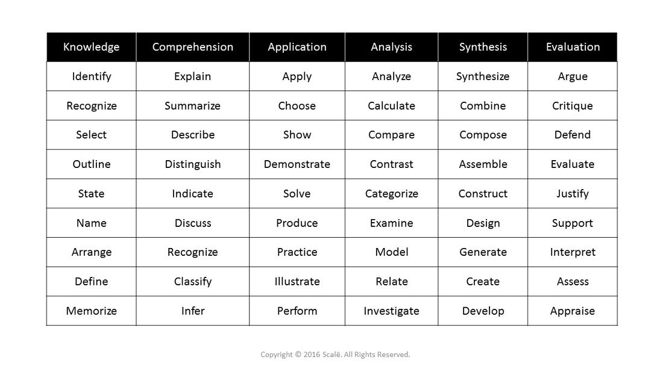

Figure 1: Actionable Verbs Examples

# METHODOLOGY

Use methodology which best fits your approach to develop a software solution to a given problem. A methodology is a series of processes or phases, which helps you define which stage you are at the given period of time.

You can use iterative model, Waterfall model(with Explicit Feedback loop), Agile model(*not preferable for first project, but. explore*), V model(Verification and validation model). However, avoid mentioning RAD, Spiral model as the SDLC methodology in your project proposal, because it is not the method to be followed in a simpler project model.

# DATA FLOW DIAGRAM

It is a **diagrammatic representation** that portrays the **flow of data** in a system or a process.

Helps communicates the **general data flow** structure of a proposed system to the system designer, programmer and end-users.

Helps assess the requirements, so a major process for **requirement analysis.**

**Outputs and inputs** are clearly defined.

**However,** there are no decision rules and iteration(loops).

There are 4 basic symbols.

# PROJECT GANTT CHART/ TIMELINE CHART

It is a timeline of the project developed by Henry Gantt, also called project schedule chart.

In the vertical axis defines the tasks to be performed, on the vertical axis, and time intervals on the horizontal axis.

The gantt chart contains the following information:

1. Start and End data of the project.
2. Completed project tasks, which are represented by a unique colored notation, can be shaded, or colored in gray color.
3. Duration of the tasks, how many days will it take to complete the tasks.

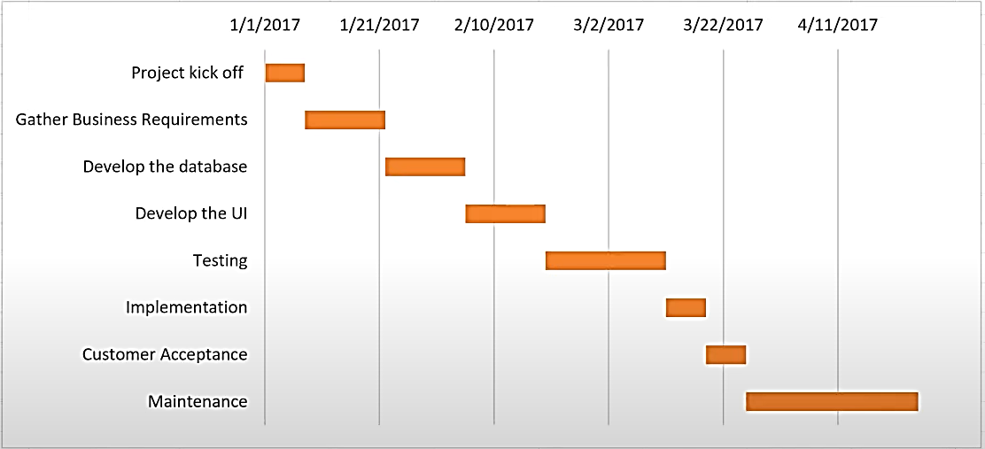

Figure 2: Example of Gantt Chart

# DELIVERABLES

It is the products, services, reports, results or anything that is obtained after the completion of the project.

It can also be the outcome, responses from the end-users. Some examples of the deliverables are:

* Project report or project documentation: Explain what summarized contents are there.
* User manual and system requirements: explain it but not in-depth, one or two lines only.
* Software, applications, or digital solutions: explain it but not in-depth, one or two lines only.
* System Design: ERD, DFD, FLOW CHART.
* Log Reports, milestones of the project, project enhancements.

# CONCLUSION

Overall summary of the project.